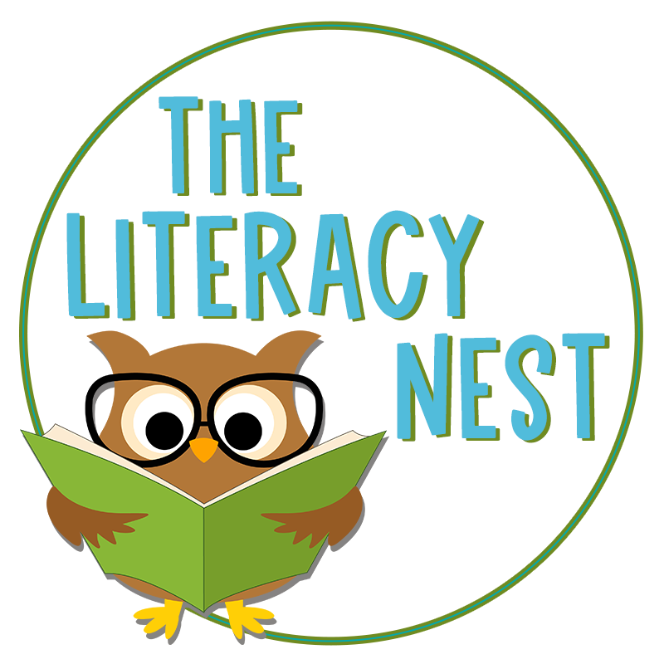
Policy Document #1

Anit-Discrimination Policy

Date of Last Update: 11/14/21

- Purpose
This policy prevents discrimination within any learning environment created by The Literacy Nest, and ensures that all individuals involved in learning events through The Literacy Nest will not encounter discrimination.

- Scope
This policy applies to all aspects of The Literacy Nest organization, including but not limited to the annual Building Readers For Life: The Literacy Nest Summer Conference. It encompasses the entirety of business operations within The Literacy Nest and all learning events or hosted through the organization. It protects all people involved, including participants, presenters, president/CEO, and support personnel.

- Policy
The Literacy Nest and the Building Readers For Life: The Literacy Nest Summer Conference is committed to providing a learning environment that is free from harassment and discrimination. Harassment or discrimination based upon an individual's race, color, religion, sex, pregnancy, sexual orientation, gender identity, national origin, disability, age, genetic information (including family medical history), or any other legally-protected characteristics will not be tolerated. All participants, including presenters and other contracted personnel, are expected and required to abide by this policy.

The Literacy Nest and the Building Readers For Life: The Literacy Nest Summer Conference will not tolerate harassment, bullying, threatening, or derogatory language in the comments or public spaces on any of its online platforms, and reserves the right to ban any participant, presenter, or support personnel who have been determined to be behaving in a negative or harassing manner.

- Roles & Responsibilities
The president/CEO of The Literacy Nest will be responsible for enforcing this policy and addressing any potential violations.

- Reporting & Violations
If a participant, presenter, or support personnel feel they have been harassed or discriminated against on the basis of their race, color, religion, sex, pregnancy, sexual orientation, gender identity, national origin, disability, age, genetic information (including family medical history), or any other legally-protected characteristic, they should immediately report the matter to The Literacy Nest president/CEO via email at emilygibbons@theliteracynest.com. Once the matter has been reported it will be promptly investigated by the president/CEO and necessary corrective action will be taken where appropriate. Corrective action may include: removing an individual from participation in the learning event, removing a presenter from their role in the learning event, preventing future participation or presentation, monetary refunds, or contacting local authorities.

All complaints of unlawful harassment will be handled in as discreet and confidential a manner as is possible under the circumstances. No person will be adversely affected in their standing with The Literacy Nest as a result of bringing complaints of harassment or discrimination.

Revision History
11/14/21: Policy created

Policy Document #2

Vested Interest Disclosure Policy

Date of Last Update: 11/14/21

- Purpose
This policy ensures the disclosure of any vested interest in a product, instrument, device, or materials used in a learning event to maintain full transparency between The Literacy Nest, presenters, and participants.

- Scope
This policy applies to any learning event hosted or created by The Literacy Nest organization, including but not limited to the annual Building Readers For Life: The Literacy Nest Summer Conference.

- Policy
All presenters and representatives of the Building Readers For Life: The Literacy Nest Summer Conference or any learning event hosted by The Literacy Nest are required to disclose any affiliation or vested interest in any product or materials that may be used in their presentation video, teaching materials, or discussion board interactions. If the instructor receives any share of royalties or profits from the product promotion or endorsement, the instructor will disclose this connection in writing on a slide during their presentation and on any relevant teaching materials.

- Roles & Responsibilities
The president/CEO of The Literacy Nest will be responsible for enforcing this policy and addressing any potential violations.

- Reporting & Violations
If a presenter neglects to disclose a vested interest, the President/CEO of The Literacy Nest will inform all participants of that learning event upon discovery of the connection. Any participants suspecting a possible vested interest that was not disclosed should report the matter to The Literacy Nest president/CEO via email at emilygibbons@theliteracynest.com. Once reported, the possible interest will be investigated by the president/CEO and necessary corrective action will be taken where appropriate. Corrective action may include: removing a presenter from their role in the learning event, preventing future participation or presentation, or monetary refunds.

No person will be adversely affected in their standing with The Literacy Nest as a result of bringing complaints of undisclosed vested interest.

Revision History
11/14/21: Policy created

Policy Document #3

Intellectual Property Rights Policy

Date of Last Update: 11/14/21

- Purpose
This policy ensures the respect of ownership rights of intellectual property among all presentations and teaching materials used in a learning event hosted or created by The Literacy Nest.

- Scope
This policy applies to any learning event hosted or created by The Literacy Nest organization, including but not limited to the annual Building Readers For Life: The Literacy Nest Summer Conference.

- Policy
The Literacy Nest and the Building Readers For Life: The Literacy Nest Summer Conference requires appropriate adherence to intellectual property rights by both presenters and participants.

As part of the Presenters Agreement, presenters agree that they will adequately investigate and adhere to the acceptable use policy of any media or work that is included in their presentations.

Participants agree, upon registration, to acknowledge that use of any portion of a presentation or supplemental materials is subject to copyright and may only be done upon proof of written permission. The Literacy Nest agrees to maintain a file of granted permission requests. Usage of any copyrighted material, upon granted permission, should be appropriately cited.

- Roles & Responsibilities
The president/CEO of The Literacy Nest will be responsible for enforcing this policy and addressing any potential violations.

- Reporting & Violations
Any participants or presenters suspecting a possible copyright infringement should report the matter to The Literacy Nest president/CEO via email at emilygibbons@theliteracynest.com. If the material is determined to not have written permission on file at The Literacy Nest, the organization will remove the relevant material from the learning management system (LMS) and inform relevant participants and presenters that the material should not be disseminated or used.

No person will be adversely affected in their standing with The Literacy Nest as a result of bringing complaints of possible infringement of copyright.

Revision History
11/14/21: Policy created

Policy Document #4

Qualification Requirements Policy

Date of Last Update: 11/14/21

- Purpose
This policy ensures the qualifications of people involved in learning events hosted or created by The Literacy Nest are reviewed regularly and deemed to be satisfactory for involvement in the learning event.

- Scope
This policy applies to any presenter or support person involved in a learning event hosted or created by The Literacy Nest organization, including but not limited to the annual Building Readers For Life: The Literacy Nest Summer Conference. It includes presenters and contracted support personnel who may be involved in course design, development, delivery, evaluation, or administration.

- Policy
The Literacy Nest shall review the credentials of all presenters and support personnel involved in the Building Readers For Life: The Literacy Nest Summer Conference or any learning event created hosted by The Literacy Nest to ensure subject matter expertise and relevant competencies.

Presenters: Upon contracting with The Literacy Nest as a conference presenter, the subject matter experts (SMEs) shall provide resumes that include relevant educational and professional experience, licenses, and certifications. The Literacy Nest president/CEO shall review these resumes and credentials (and research additional context within the subject matter as needed), and the resumes shall be kept on file.

Support Personnel: Individuals contracted as support personnel may include marketing professionals, learning management system managers, or administrative assistants. The Literacy Nest president/CEO shall review the resumes and credentials of each of these contracted personnel to ensure they adequately represent the function they will be performing. These resumes shall be kept on file.

- Roles & Responsibilities
The president/CEO of The Literacy Nest will be responsible for collecting and reviewing the resumes and credentials of all presenters and support personnel, as well as determining the existence of all relevant competencies.

- Reporting & Violations
Any participants or presenters with concerns regarding the relevant competencies of any presenter or support personnel shall share these concerns with The Literacy Nest president/CEO via email at emilygibbons@theliteracynest.com. The president/CEO will then conduct the needed research and inquiries to determine the validity of these concerns. Any presenter or support person found to hold inadequate experience shall be removed from their position until the time that such qualifications are acquired.

No person will be adversely affected in their standing with The Literacy Nest as a result of sharing concerns related to the qualifications of any presenters or support personnel.

Revision History
11/14/21: Policy created

Policy Document #5

Course Content Review Policy

Date of Last Update: 11/14/21

- Purpose
This policy ensures course content in any learning event hosted or created by The Literacy Nest is reviewed for quality, currency, effectiveness, and applicability. Any course content used in a learning event must attain satisfactory achievement in all these categories.

- Scope
This policy applies to the content of any learning event hosted or created by The Literacy Nest organization, including but not limited to the annual Building Readers For Life: The Literacy Nest Summer Conference.

- Policy
The president/CEO of The Literacy Nest shall review all course content when it is submitted by the presenter for use in the learning event. In order to be used in the learning event, each piece of content—including, but not limited to, instructional videos and handouts—shall be determined to satisfy requirements in its quality, currency, effectiveness, and applicability to the course subject.

Any content determined to not satisfy the four requirements shall be returned to the submitting presenter with a communication detailing the necessary changes needed to improve the quality. Any presenter unable to make these necessary changes shall be removed as a presenter for that learning event.

- Roles & Responsibilities
The president/CEO of The Literacy Nest will be responsible for collecting and reviewing all submitted learning materials, as well as deciding when improvements are needed and communicating those improvements to the presenter.

- Reporting & Violations
Any content determined to not satisfy the four requirements shall be returned to the submitting presenter with a communication detailing the necessary changes needed to improve the quality. Any presenter unable to make these necessary changes shall be removed as a presenter for that learning event.

If content is determined to be insufficient following changes from the presenter, The Literacy Nest president/CEO shall inform the presenter that their learning event will not take place, nor will they receive monetary compensation for the submitted materials.

Revision History
11/14/21: Policy created

Policy Document #6

Personal Records Security Policy

Date of Last Update: 11/14/21

- Purpose
This policy ensures that records of The Literacy Nest learning event participants shall be kept private and secure.

- Scope
This policy applies to the digital or hardcopy personal records of participants in any learning event hosted or created by The Literacy Nest, including but not limited to the annual Building Readers For Life: The Literacy Nest Summer Conference. Personal records may include name, address, CEU history, contact information, and other personal information.

- Policy
The Literacy Nest shall maintain personal records of all learning event participants. These records will be kept as up-to-date as possible, and stored in a secure location such as an on-site filing system, digital records on The Literacy Nest hardware, or digital records located within the learning management system. The information shall be considered confidential and shared only upon written permission or request from the participant. The Literacy Nest shall ensure all available steps are taken to secure information stored, including but not limited to locking office doors, locking cabinets, and ensuring any cloud-stored digital content is kept in a reputable, secure domain.

- Roles & Responsibilities
The president/CEO of The Literacy Nest will be responsible for maintaining the personal records of learning event participants, ensuring they are kept confidential and secure.

- Reporting & Violations
Any detected breach in the security of personal information hosted by The Literacy Nest shall be communicated to all relevant learning event participants to warn of potential information-sharing.

Any learning event participant who has sufficient reason to suspect their personal information held by The Literacy Nest has been shared without permission shall communicate this to the president/CEO via email at emilygibbons@theliteracynest.com. The president/CEO shall investigate any suspicion of a security breach accordingly. If a breach is detected, that information shall be shared with all relevant learning event participants, and steps shall be taken to prevent similar breaches in the future.

Revision History
11/14/21: Policy created

